**18XT58: JAVA PROGRAMMING LAB**

***Package: Smart City Application***

V.Aishwarya- 19PT31

**Project Abstract**

The Smart City project is a web-based software application built to store all the essential details of a city. Cities and urban areas witness a massive wave of people coming from every corner in search of jobs, education, and even a better lifestyle. In the initial days after the move, people don’t know the main facilities, attractions, and services offered in the city. The smart city project seeks to address that by creating an integrated platform to store essential and related information to guide the newcomers in a city.

The application will provide visitors, students, and job seekers information like hotels, renting facilities, transportation services, healthcare services, airline ticket booking, shopping landmarks, emergency helpline, and basically every information that one needs when in a new city. It is like a smart city guide for visitors.

Users can connect to the application via the Internet and browse all the smart city web pages to get the details they need. Users can see the entire map of a city along with the important landmarks. This will make their movement across the city much more comfortable.

The smart city application has five modules:

* Administration module – It is the central controller of the application. It uploads all the new information on the site and authenticates user profiles, and supervises the maintenance of the other four modules.
* Tourism module – As the name suggests, this module handles all the tourism-related operations in the city, such as hotels, restaurants, tourist attractions, ATMs, theatres, and so on. A user authenticated by the administration module becomes the primary user of this module.
* Student module – This module is designed specifically for helping students move around the city. It contains all the academia related information for students, including the location of best educational institutes, libraries, coaching centers, technical colleges, universities, colleges, etc.
* Jobseekers module – This module contains important information on the job opportunities available in the city. Users can access all kinds of job-related information across various industries. The main objective of this module is to help the city administration to combat unemployment problems in the city.
* Business module – This module focuses on offering business-related news, information, and opportunities in the city. Users can access information on trade and business centers and industries in the city.

**UML Diagrams**

1. Class Diagram

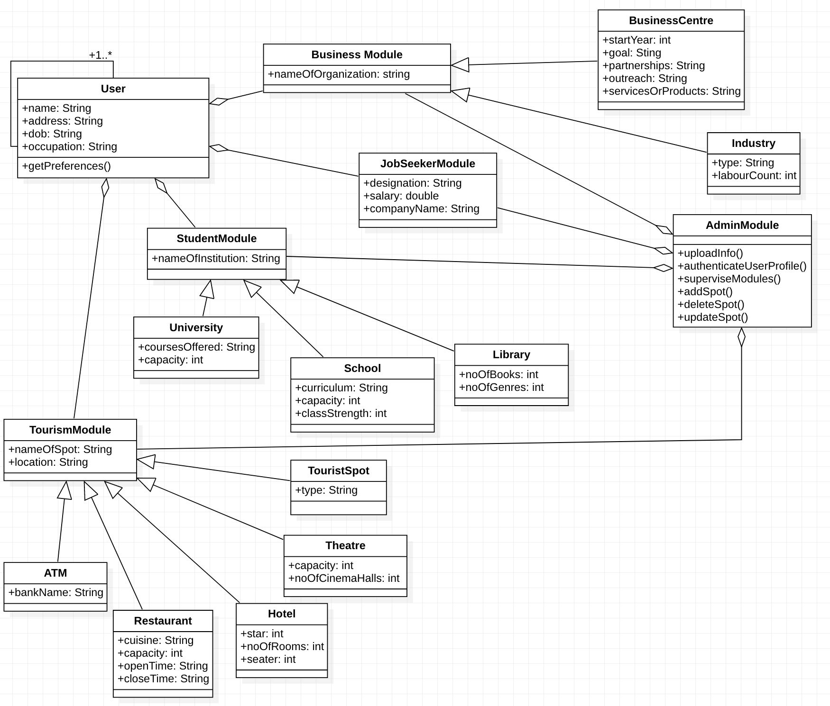

1. Linktovideo: https://drive.google.com/file/d/11CPKcr8pexabv58_sSDoy0kEO3OX7uaC/view?usp=sharing